# FINAL REPORT ON

**STUDENT STUDY PORTAL**



# Submitted for the partial fulfillment for the award of the degree of the

## Bachelor of Technology IN

**(Computer Science & Engineering)**

## SUBMITTED BY:

**Sahil: 1809424**

## Nikhil Dhiman: 1908578

**SUBMITTED TO:**

## Dr. Dinesh Garg

**DEPARTMENT OF COMPUTER SCIENCE & ENGINEERING SRI SAI COLLEGE OF ENGINEERING AND TECHNOLOGY**

# FINAL REPORT ON

**STUDENT STUDY PORTAL**

# Submitted for the partial fulfillment for the award of the degree of the

## Bachelor of Technology IN

**(Computer Science & Engineering)**



## SUBMITTED BY:

**Sahil: 1809424**

## Nikhil Dhiman: 1908578

**SUBMITTED TO:**

## Dr.Dinesh Garg

**DEPARTMENT OF COMPUTER SCIENCE & ENGINEERING SRI SAI COLLEGE OF ENGINEERING AND TECHNOLOGY BUNGAL, PATHANKOT**

# TABLE OF CONTENTS

## Topic Page No.

Declaration 4

|  |  |
| --- | --- |
| Abstract | 5 |
| Acknowledgement | 6 |
| Introduction to the organization | 7 |
| **Chapter 1:**  Introduction of the project | 8-10 |
| **Chapter 2:**  Technology Used | 11-15 |
| .Imported Libraries and Components | 16 |
| **Chapter 3:**  Feasibility Study | 17-18 |
| **Chapter 4:**  Methodology | 19 |
| code and explanation | 20-22 |
| **Chapter 5:**  Results and Discussions | 23-24 |
| **Chapter 6:**  Conclusion and future scope | 25 |
| **Bibliography**  Website referred | 26 |
| Reference Books | 26 |

**DECLARATION**

We, hereby declares that we have undertaken 6 months Software Training at excellence technology during a period from January 2021 to June 2022 in partial fulfillment of requirements for the award of degree of B.Tech. (Computer Science & Engineering) at SRI SAI COLLEGE OF ENGINEERING AND TECHNOLOGY, BUNGAL (PATHANKOT).

The work which is being presented in the training report submitted to Department of Computer Science & Engineering at SRI SAI COLLEGE OF ENGINEERING AND TECHNOLOGY, BUNGAL(PATHANKOT) is an authentic record of training work.

Dated: 16 -JUNE-2022

SAHIL:1809424 NIKHIL DHIMAN: 1908578 B.TECH 8TH Sem

# ABSTRACT

We have done my six months industrial training at excellence technology . to improve our technical abilities in computer science.

Our topic for this training was to learn the concepts of website development and how to create an website. The design of such an application uses django and flask and the coding language used is python. We have used to learn website development and to create my project. The purpose of the final application is to help kids to develop important skills needed in school and promote bonding between parents and kids.

This training allowed me to increase my knowledge and skills in programming and developing application for website platform.

# ACKNOWLEDGEMENT

The successful completion of this training marks the beginning of an ever-going learning experience of converting ideas and concepts into real life and practical system. This training is a quite learning experience for me at each and every step. At the same time, it has given me the confidence to work in professional setup as website Development is very booming technology nowadays. We feel the experience gained during this training will lead me to gain bright prospect in the future. we would like to thank Miss. Anjali CEO, Excellence Technology for giving me the opportunity to do my training within the organization.

We also would like to thank all the people that worked along with me at excellence technology With their patience and openness, they created an enjoyable working environment.

It is indeed with a great sense of pleasure and immense sense of gratitude that we acknowledge the help of these individuals.

We are highly indebted to SRI SAI COLLEGE OF ENGINEERING AND TECHNOLOGY for the facilities provided to accomplish this training.

We would like to thank our teacher Mr. Sourav Yadav for his constructive criticism throughout my training. His guidance, support and motivation enabled me to achieve the goals of the training.

Sahil (1809424)

Nikhil Dhiman (1908578) B.TECH CSE 8th sem

## Introduction to the Organization

Excellence Technology is one of the top reputed ISO 9001:2015 Certified Software Development Company in Chandigarh, Mohali and Panchkula We develop a mobile application, Games, antivirus and websites.We provide Best Php, Java, Web Designing and Android training on live projects of our off shore clients. We provide affordable deals in Website Designing and Development with a wide spectrum of courses in software, networking, automation, digital marketing, MBA and many more with a state-of-the-art infrastructure and spacious classrooms at Excellence Technology.

We provide the best learning environment for our students where they can develop their skills. Best Digital Marketing training in Chandigarh, Mohali and Panchkula, SEO/SMO, ORM (Online Reputation Management), Apart from that we also provide Best job oriented courses in Chandigarh.100% Practical training on real-time projects with a stipend.Students who are capable can get a stipend based internship or training in Chandigarh on PHP, web designing, android and digital marketing.

Excellence Technology is one of the top reputed ISO 9001:2015 Certified Software Development Company in Chandigarh, Mohali and Panchkula We develop a mobile application, Games, antivirus and websites.We provide Best Php, Java, Web Designing and Android training on live projects of our off shore clients. We provide affordable deals in Website Designing and Development with a wide spectrum of courses in software, networking, automation, digital market

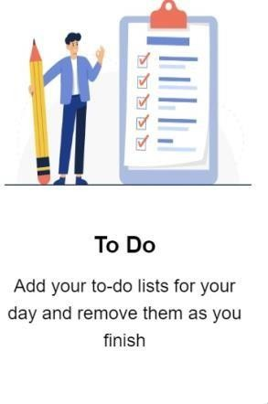

# CHAPTER - 1

**1. INTRODUCTION OF PROJECT**

Student study portal is a portal with following features in its dashboard to make students life easy and more manageable.

1. In this project users can create text notes and refer them later, they are store permanently until deleted.

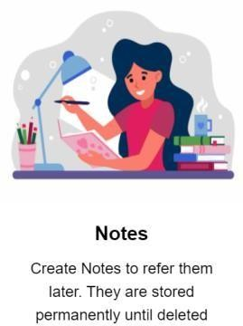

1. Users can add homework and assign them deadlines, they will be displayed prioritized by deadlines

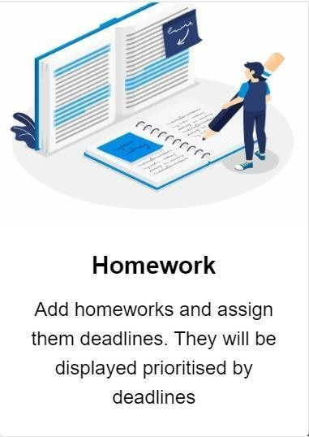

1. Users can add to do list for their day and remove them as the work is finished.
2. Users can browse books from a list of neatly organized book menu.

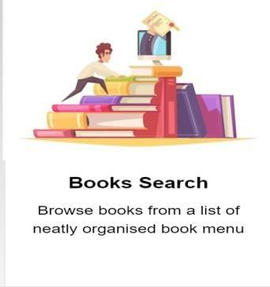

1. Users can enter a word and the meaning will be displayed along with its phonetic description incautiously.

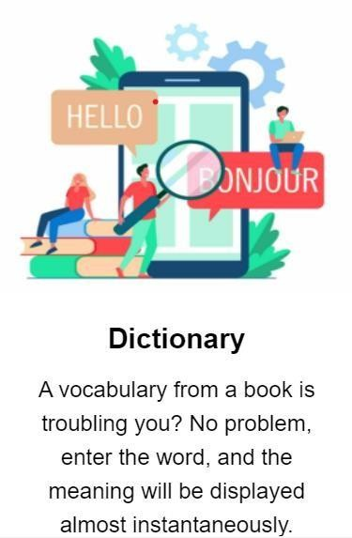

1. Users can search Wikipedia to get fast results.

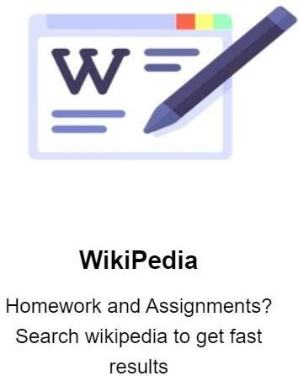

1. A virtual wallet is implemented to help the users to manage their expenses and keep track of it

.

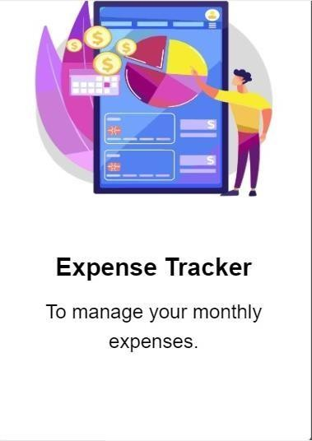

# CHAPTER -2

**2.1 TECHNOLOGY USED:**

**Python -** Python is a popular programming language. It was created by Guido van Rossum, and released in 1991.

It is used for:

* web development (server-side),
* software development,
* mathematics,
* system scripting
* Python can be used on a server to create web applications.
* Python can be used alongside software to create workflows.
* Python can connect to database systems. It can also read and modify files.
* Python can be used to handle big data and perform complex mathematics.
* Python can be used for rapid prototyping, or for production-ready software development.



**Django -** Django is an advanced Web framework written in Python that makes use of the model view controller (MVC) architectural pattern. Django was created in a fast-moving newsroom environment, and its key objective is to ease the development of complicated, database-driven websites. This Web framework was initially developed for The World Company for managing some of their news-oriented sites. In July 2005, it was publicly released under a BSD license

Django is available as an open-source Web framework, and it uses Python extensively to create files, settings and data models. It is designed to address two main challenges: the rigorous requirements of highly experienced Web developers and the intense deadlines of a newsroom. Django concentrates more on automating wherever possible and sticking to the "don't repeat yourself" principle.

Django emphasizes the following:

* Pluggability and reusability of components
* Quick development
* The principle of non-repetition

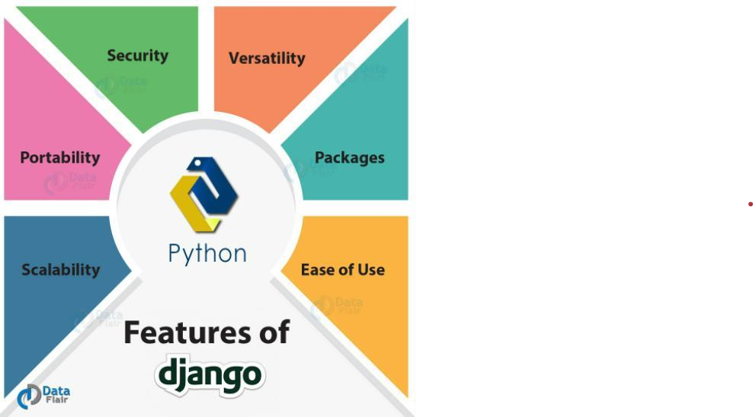

**Flask -** A web framework is a software architecture that contains tools and libraries used to develop a web application in a fast and efficient way. Flask is a microframework written in Python. It was developed by Armin Ronacher and has a BSD license. It is based on the Werkzeug toolkit and Jinja2 template. Here,

1. **WSGI (Web Server Gateway Interface):** It is used as a universal interface between the web server and the web application
2. **Werkzeug**: It is a WSGI toolkit and is used for implementing requests, response objects, and other utilities. It is used to build a web framework on top of it.
3. **Jinja2**: It is a templating engine that combines a template and a data source to develop a dynamic website.

It provides only core functionalities including form validation, upload handling, object-relational mappers, open authentication, etc. Using these, one can build both small and large scale websites. It does not have a database abstraction layer, form validation, and additional functionalities but it provides extensions to implement these

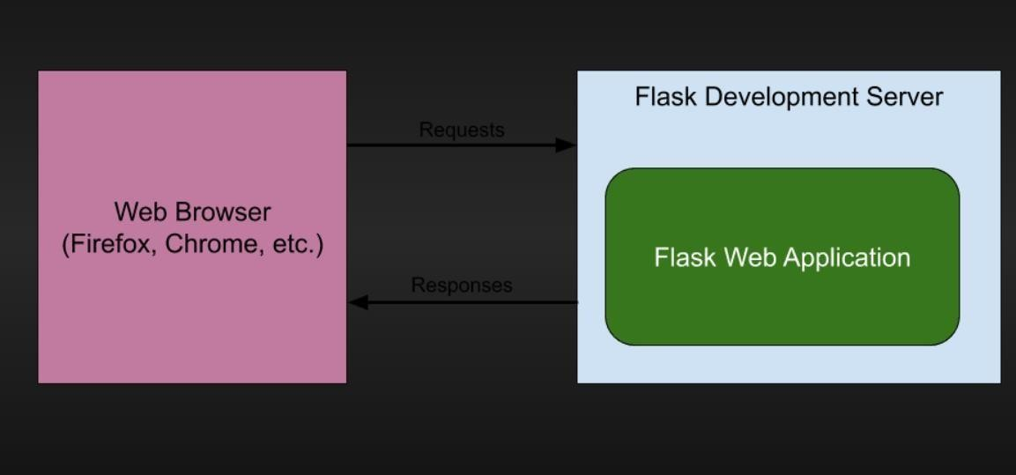

**HTML -** HTML stands for HyperText Markup Language. It is used to design web pages using a markup language. HTML is the combination of Hypertext and Markup language. Hypertext defines the link between the web pages. A markup language is used to define the text document within tag which defines the structure of web pages. This language is used to annotate (make notes for the computer) text so that a machine can understand it and manipulate text accordingly. Most markup languages (e.g. HTML) are human-readable. The language uses tags to define what manipulation has to be done on the text.

HTML is a markup language used by the browser to manipulate text, images, and other content, in order to display it in the required format. HTML was created by Tim Berners-Lee in 1991. The first-ever version of HTML was HTML 1.0, but the first standard version was HTML 2.0, published in 1995

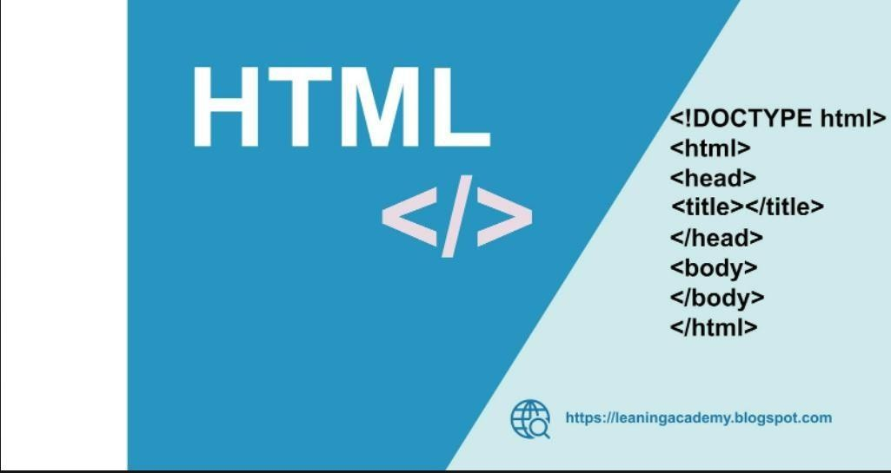

**CSS - C**ascading **S**tyle **S**heets, fondly referred to as CSS is a simply designed language intended to simplify the process of making web pages presentable. CSS allows you to apply styles to web pages. More importantly, CSS enables you to do this independent of the HTML that makes up each web page.

CSS is easy to learn and understand, but it provides powerful control over the presentation of an HTML document.

* **CSS saves time:** You can write CSS once and reuse the same sheet in multiple HTML pages.
* **Easy Maintenance:** To make a global change simply change the style, and all elements in all the webpages will be updated automatically.
* **Search Engines:** CSS is considered a clean coding technique, which means search engines won’t have to struggle to “read” its content.
* **Superior styles to HTML:** CSS has a much wider array of attributes than HTML, so you can give a far better look to your HTML page in comparison to HTML attributes.
* **Offline Browsing:** CSS can store web applications locally with the help of an offline cache. Using this we can view offline websites

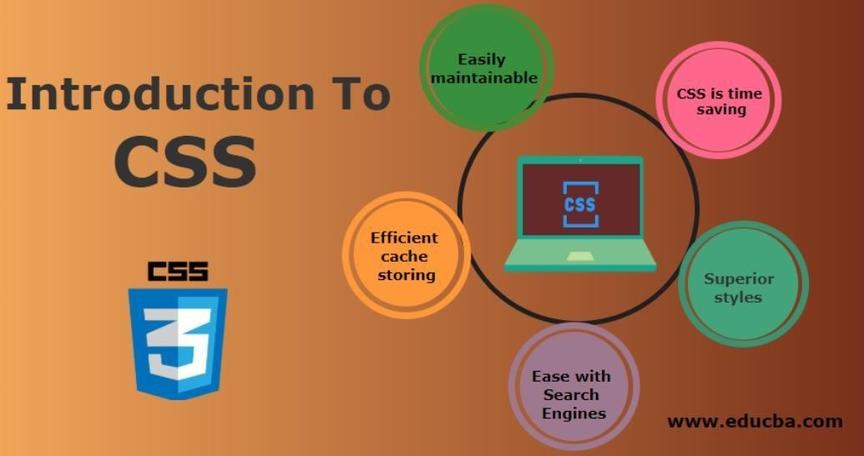

**Bootstrap -** It is an open-source and free CSS framework, which helps in directing a responsive device- friendly mobile-first front-end web page development tool. Bootstrap includes the CSS (Cascading Style Sheets), and an optional JavaScript supported design template (plug-ins) that deals with typography, implementation of buttons, forms, and various other components user interface. This framework helps in faster web development and supports developers in creating responsive web pages faster.

* + **Browser supportive**: Every browser supports this Bootstrap Framework.
  + **Mobile-first approach**: In the Bootstrap 3 framework, there is a preexisting mobile-first style all through the library and not as separate files.
  + **Simple and easy to start**: If you know HTML and CSS, you can quickly start working with Bootstrap, and its documentation is provided on the official site.
  + **Responsive design and looks**: Web pages designed using the Bootstrap framework has responsive CSS that can adjust to the screen size of large desktops, notebooks, tablets, and mobiles.

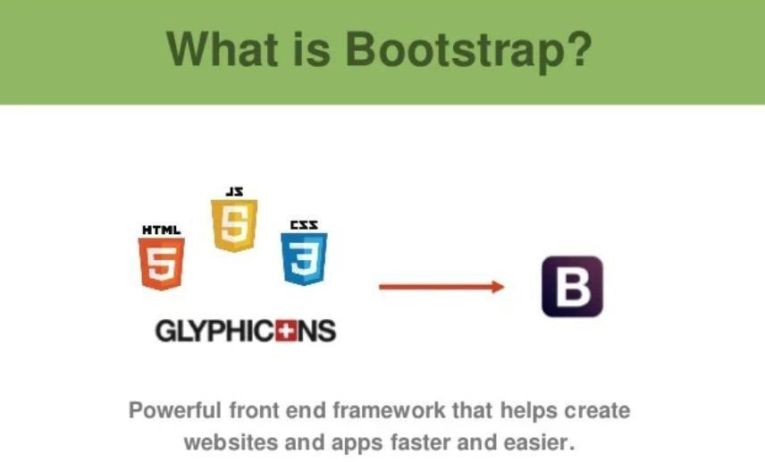

**JavaScript -** JavaScript is a lightweight, cross-platform, and interpreted compiled programming language which is also known as the scripting language for webpages. It is well-known for the development of web pages, many non-browser environments also use it. JavaScript can be used for client side developments as well as server-side developments. JavaScript contains a standard library of objects, like array, date and math and a core set of language elements like operators**,** control structures**,**

and statements

JavaScript can be added to your HTML file in two ways:

* **Internal JS:** We can add JavaScript directly to our HTML file by writing the code inside the <script> tag. The <script> tag can either be placed inside the <head> or the <body> tag according to the requirement.
* **External JS:** We can write JavaScript code in other file having an extension .js and then link this file inside the <head> tag of the HTML file in which we want to add this code.

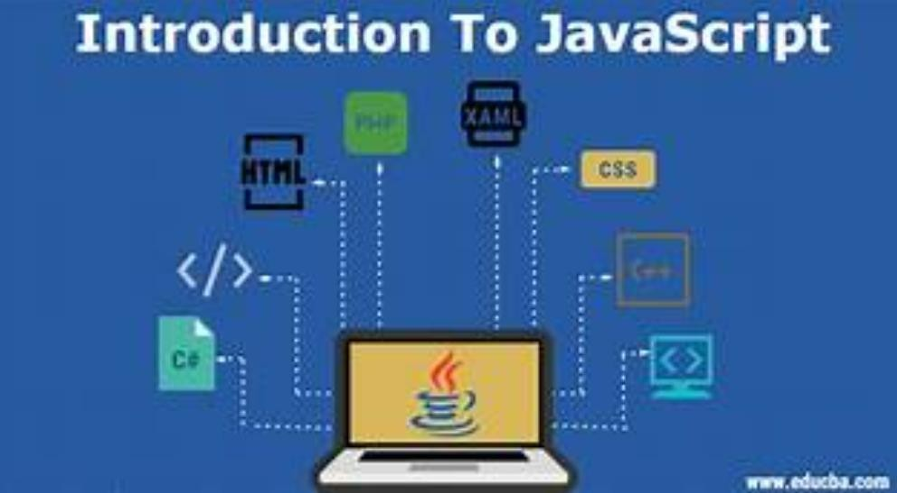

## API Required :-

**Dictionary API:-** API is the acronym for Application Programming Interface, which is a software intermediary that allows two applications to talk to each other. Each time you use an app like Facebook, send an instant message, or check the weather on your phone, you're using an API

**Google e-books API:-** Google books is our effort to make book content more discoverable on the Web. Using the Google Books API, your application can perform full-text searches and retrieve book information, view ability and eBook availability. You can also manage your personal bookshelves

**Django-crispy-forms:-** Django-crispy-forms is an application that helps to manage Django forms. It allows adjusting forms' properties (such as method, send button or CSS classes) on the backend without having to re-write them in the template

## Imported libraries and components :-

1.python django_web_app/manage.py makemigrations 2.python django_web_app/manage.py migrate 3.python django_web_app/manage.py runserver 4.mysql connector

5.import pillow

# CHAPTER 3

* 1. **FEASIBILITY STUDY**

Feasibility study is made to see if the project on completion will serve the purpose of the organization for the amount of work, effort and the time that spend on it. Feasibility study lets the developer foresee the future of the project and the usefulness. A feasibility study of a system proposal is according to its workability, which is the impact on the organization, ability to meet their user needs and effective use of resources. Thus, when a new application is proposed it normally goes through a feasibility study before it is approved for development.

## Technical Feasibility:

The system must be evaluated from the technical point of view first. The assessment of this feasibility must be based on an outline design of the system requirement in the terms of input, output, programs and procedures. Having identified an outline system, the investigation must go on to suggest the type of equipment, required method developing the system, of running the system once it has been designed. Technical issues raised during the investigation are:

* Does the existing technology sufficient for the suggested one?
* Can the system expand if developed?

The project should be developed such that the necessary functions and performance are achieved within the constraints.

## Economic Feasibility:

The developing system must be justified by cost and benefit. Criteria to ensure that effort is concentrated on project, which will give best, return at the earliest. One of the factors, which affect the development of a new system, is the cost it would require.

* The costs conduct a full system investigation.
* The cost of the hardware and software.
* The benefits in the form of reduced costs or fewer costly errors.

Since the system is developed as part of project work, there is no manual cost to spend for the proposed system. Also all the resources are already available, it give an indication of the system is economically possible for development.

## Behavioral Feasibility:

This includes the following questions:

* Is there sufficient support for the users?
* Will the proposed system cause harm?

The project would be beneficial because it satisfies the objectives when developed and installed. All behavioral aspects are considered carefully and conclude that the project is behaviorally feasible

# CHAPTER - 4

**METHODOLOGY:** The part where I tell you what are the basic requirement for this project. You’ll need following: -

* + 1. Python: Python is a high-level, general-purpose programming language. Its design philosophy emphasizes code readability with the use of significant indentation. Its language constructs and object oriented approach aim to help programmers write clear, logical code for small- and large-scale projects
    2. Django: Django is a Python-based web framework that allows you to quickly create efficient web applications. It is also called batteries included framework because Django provides built-in features for everything including Django Admin Interface, default database – SQLlite3, etc. When you’re building a website, you always need a similar set of components: a way to handle user authentication (signing up, signing in, signing out), a management panel for your website, forms, a way to upload files, etc. Django gives you ready-made components to use and that too for rapid development.
    3. Bootstrap: Bootstrap is the popular HTML, CSS and JavaScript framework for developing a responsive and mobile friendly website.
    4. JavaScript: JavaScript is a lightweight, cross-platform, and interpreted scripting language. It is well known for the development of web pages many non-browser environments also use it. JavaScript can be used for Client-side developments as well as Server-side development

# Code and Explanation:

**Code :-**

# Generated by Django 3.2.9 on 2021-11-14 04:49

from django.conf import settings

from django.db import migrations, models import django.db.models.deletion

class Migration(migrations.Migration): initial = True

dependencies = [ migrations.swappable_dependency(settings.AUTH_USER_MODEL),

]

operations = [ migrations.CreateModel(

name='Notes', fields=[

('id', models.BigAutoField(auto_created=True, primary_key=True, serialize=False, verbose_name='ID')),

('title', models.CharField(max_length=200)), ('description', models.TextField()), ('user',

models.ForeignKey(on_delete=django.db.models.deletion.CASCADE, to=settings.AUTH_USER_MODEL)),

],

),

]

from django.conf import settings

from django.db import migrations, models import django.db.models.deletion

class Migration(migrations.Migration): dependencies = [

migrations.swappable_dependency(settings.AUTH_USER_MODEL), ('dashboard', '0001_initial'),

]

operations = [ migrations.AlterModelOptions(

name='notes',

options={'verbose_name': 'notes', 'verbose_name_plural': 'notes'},

),

migrations.CreateModel( name='Homework', fields=[

('id', models.BigAutoField(auto_created=True, primary_key=True, serialize=False, verbose_name='ID')),

('subject', models.CharField(max_length=50)), ('title', models.CharField(max_length=100)), ('description', models.TextField()),

('user', models.ForeignKey(on_delete=django.db.models.deletion.CASCADE, to=settings.AUTH_USER_MODEL)),

],

),

]

from django.conf import settings

from django.db import migrations, models import django.db.models.deletion

class Migration(migrations.Migration): dependencies = [

migrations.swappable_dependency(settings.AUTH_USER_MODEL), ('dashboard', '0001_initial'),

]

operations = [ migrations.AlterModelOptions(

name='notes',

options={'verbose_name': 'notes', 'verbose_name_plural': 'notes'},

),

migrations.CreateModel( name='Homework', fields=[

('id', models.BigAutoField(auto_created=True, primary_key=True, serialize=False, verbose_name='ID')),

('subject', models.CharField(max_length=50)), ('title', models.CharField(max_length=100)), ('description', models.TextField()),

('user', models.ForeignKey(on_delete=django.db.models.deletion.CASCADE, to=settings.AUTH_USER_MODEL)),

],

),

]

# CHAPTER 5

## 5.1 RESULTS AND DISCUSSION:

There are various activities in this project. Screenshots of each activity is below with some description.

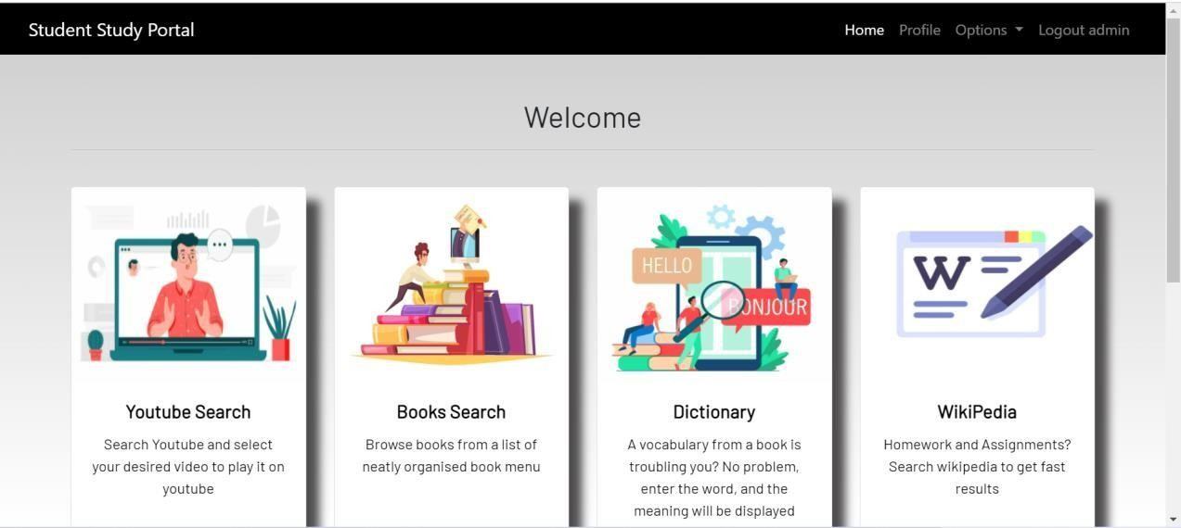

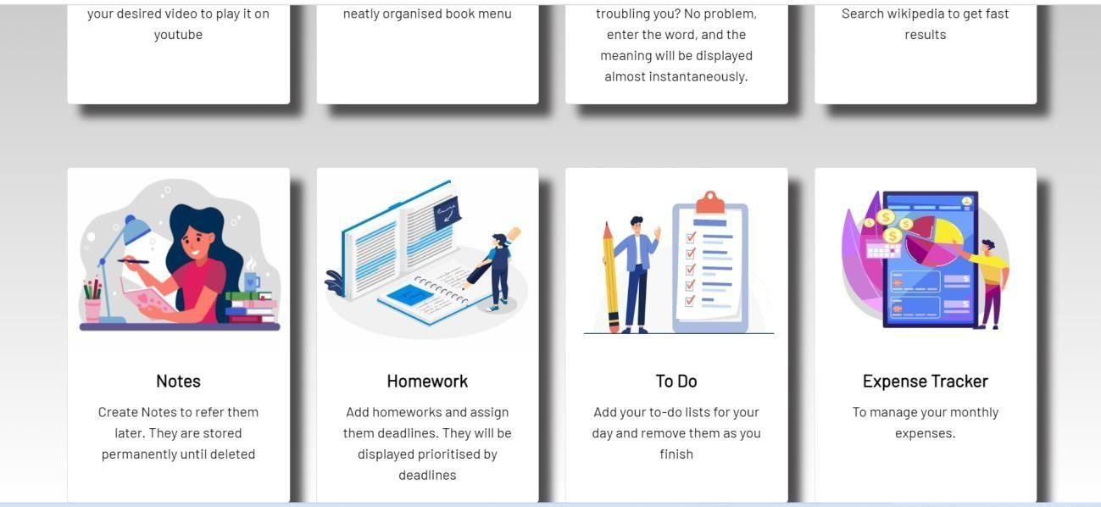

.

Student study portal is a portal with following features in its dashboard to make students life easy and more manageable.

1. In this project users can create text notes and refer them later, they are stored permanently until deleted.
2. Users can add homework and assign them deadlines, they will be displayed prioritized by deadlines .
3. Users can add to do list for their day and remove them as the work is finished.
4. Users can browse books from a list of neatly organized book menu.
5. Users can enter a word and the meaning will be displayed along with its phonetic description incautiously.
6. Users can search Wikipedia to get fast results.
7. A virtual wallet is implemented to help the users to manage their expenses and keep track of it.
8. This will display all the pending to do’s and Homework to the use

# CHAPTER 6

**CONCLUSION AND FUTURE SCOPE :**

* 1. **Conclusion:**

It is concluded that this website is working, and all its core function are also working. Any bug that we get, we removed it and will keep trying to improve this website. Making this project is one of the challenging works, which we did as Good as we can and this website will keep getting better with future updates.

## Future Scope:

The website development have bright and prosperous future ahead of it in the development software market. The fifty percent of the big companies in India nowadays earning their revenue from the web development.

Future Scope of this project is great as there are many things that can be added to this website that can make this website better than it already is. Future updates also ensure that user is getting bug free user experience. Like we can increment the counting, add more languages, add more games, and can make this website working for portrait mode.

# BIBLIOGRAPHY

**Books:**

* [1. Web Design With HTML, CSS, JavaScript and jQuery Set](https://elementor.com/blog/best-web-development-books/#web-design-with-html-css-javascript-and-jquery-set)
* [2. JavaScript: The Definitive Guide](https://elementor.com/blog/best-web-development-books/#javascript-the-definitive-guide)
* [3. Eloquent JavaScript](https://elementor.com/blog/best-web-development-books/#eloquent-javascript)
* 4. [Learning PHP, MySQL & JavaScript: With jQuery, CSS & HTML5](https://elementor.com/blog/best-web-development-books/#learning-php-mysql-javascript-css-and-html5)

**Online Sources**: **Websites**:

1. Stackoverflow, URL :-

<https://stackoverflow.com/>

accessed various time from starting to end time of project

1. tutorialspoint,URL :-https: